#F8F1EA

**Higher Education in Luzon in**

**S.Y. 2016-2017, S.Y. 2017-**

**2018, and S.Y. 2018-2019**

A research of five variables to display the current situation of higher

education in Luzon for three school years.

Study Background

Study Background

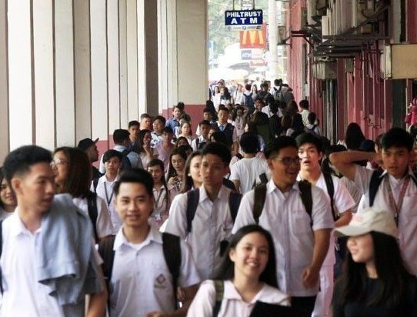

Image

This study aims to display the current situation of higher education in the Luzon Island, the major educational hub of the

Philippines, through:

checking whether all the colleges in Luzon are still within the range of the recommended faculty-to-student ratio; and

monitoring the progress of the colleges in Luzon for the S.Y. 2016-2017, S.Y. 2017-2018, and

S.Y. 2018-2019 through its student and faculty

population.

Main Content

**Number of Students**

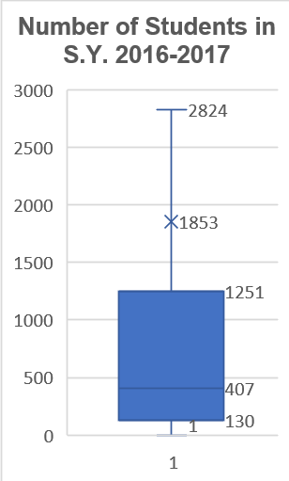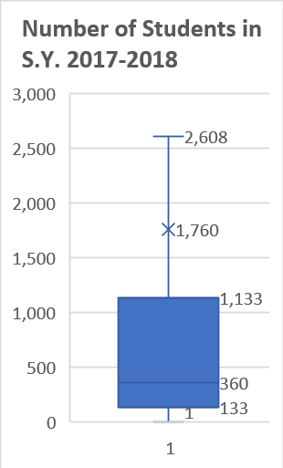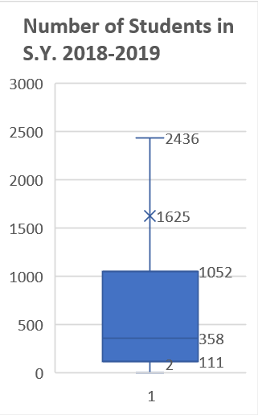

**Number of Students**

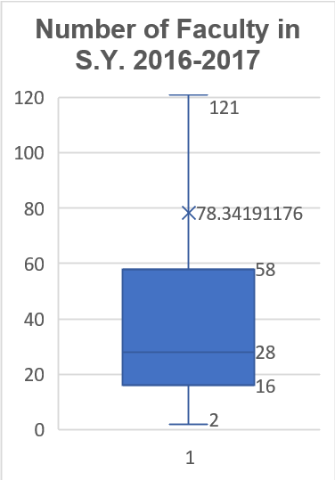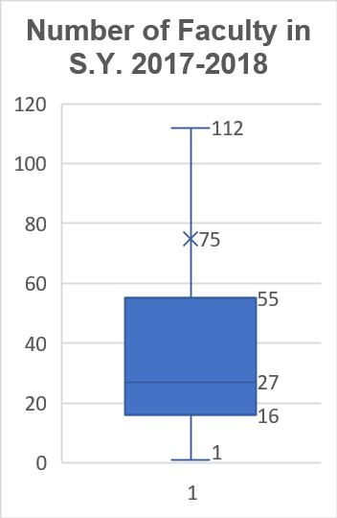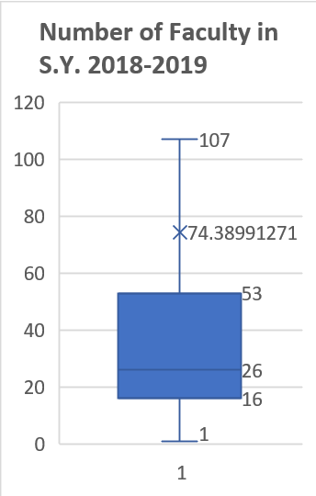

**Faculty-to-Student Ratio**

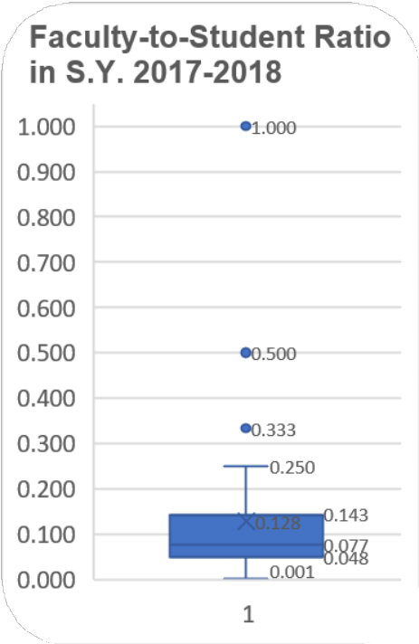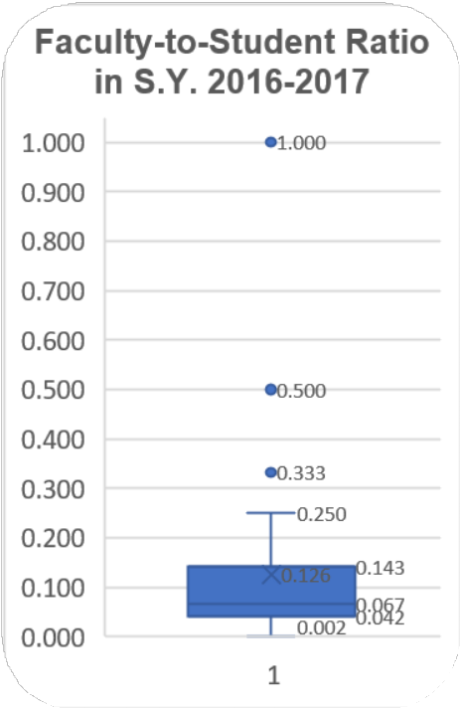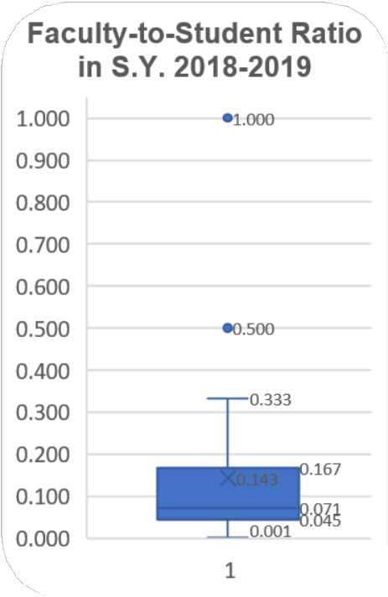

**Progress of the faculty-student ratio within the three school years**

S.Y.

2016-2017

2017-2018

2018-2019

MEDIAN

0.067

0.077

0.071

|  |  |
| --- | --- |
|  |  |
|  |  |
|  |  |
|  |  |

**The Standard**

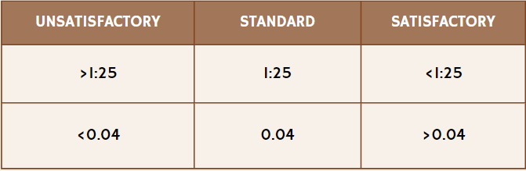

# Conclusion

 ***Hiofthliofthts***  ***Interpretation***

Declines in the number of faculty and students in Luzon

A sign that may suggest poor leadership/high rates of drop-outs/high rates of unemployment

Faculty-to-student ratio being above 0.04 for the three school years

Good standing of the faculty-student ratio

The ideal faculty-student ratio, as stipulated by DepEd Executive Order No. 349, is 1:25 (0.04 in decimal form). These parameters suggest an improvement in the faculty-to-student ratio compared to the standard. In the academic years 2016- 2017, 2017-2018, and 2018-2019, the median faculty-student ratios for colleges in Luzon were 0.067, 0.077, and 0.071, respectively. The analysis concludes that, over these three school years, the overall faculty-student ratio in state and private colleges in Luzon remained relatively satisfactory.

#F8F1EA

# References

Public vs Private Colleges: What's The Difference? - Crimson Education US. (n.d.).

Retrieved from Crimson Education:

https://[www.crimsoneducation.org/us/blog/public-vs-private-](http://www.crimsoneducation.org/us/blog/public-vs-private-) colleges/#:~:text=However%2C%20private%20colleges%20tend%20to,other%20ac ademic%20resources%20and%20technology.

Radcliff, B. (2023, September 27). How education and training affect the economy.

Retrieved from Investopedia:

https://[www.investopedia.com/articles/economics/09/education-training-](http://www.investopedia.com/articles/economics/09/education-training-) advantages.asp#:~:text=Why%20Is%20Education%20Considered%20an,greater%2 0output%20and%20economic%20growth.

Salita, D. C. (2023, October 9). Manila | Philippines, Luzon, Population, Map, Climate, & Facts. Retrieved from Encyclopedia Britannica: https://[www.britannica.com/place/Manila](http://www.britannica.com/place/Manila)

# Researchers



Arlet Carpio. Currently 14 years old.

Born on August 30, 2009 in Malaybalay City, Bukidnon. Entered and studied at Malaybalay City Central School for elementary.

Currently a student at PSHS-SMC (Philippine Science High School Southern Mindanao Campus)

Estelle Maturan Jade Dalupe